**Business Done by Railroad in Pella, Iowa, 1873**

[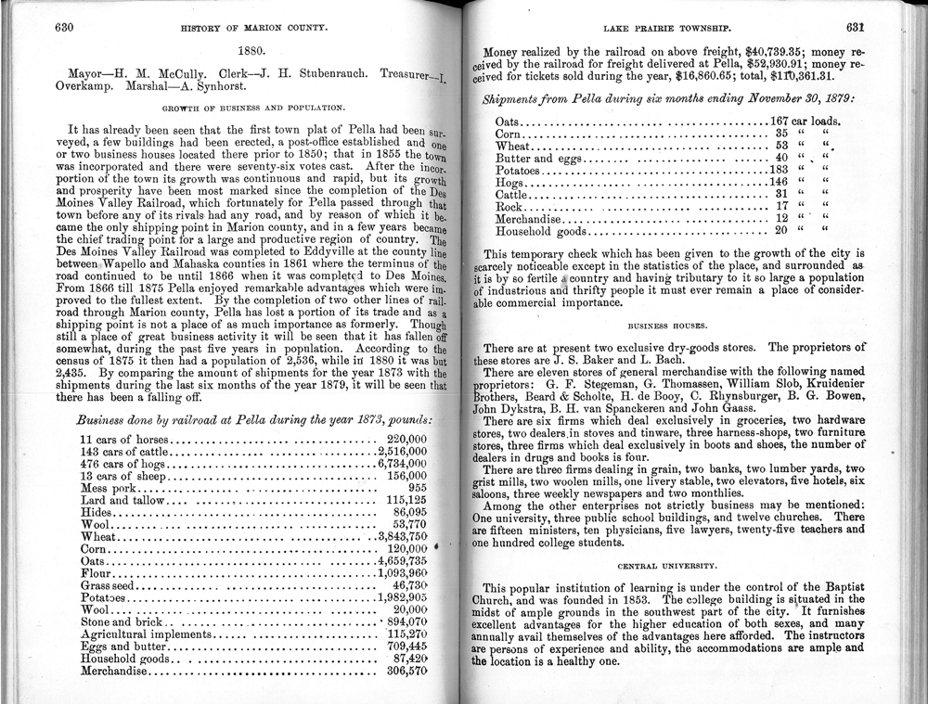](https://iowaculture.gov/sites/default/files/primary-sources/images/history-education-pss-geography2-pella-source2.jpg)

"History of Marion County, Iowa," Marion County Genealogical Society, October 1975.

**Title:** Business Done by Railroad in Pella, Iowa, 1873

**Description:** This chart from 1873 shows commodities shipped to and from Pella, Iowa. The information was collected and published by the Marion County Genealogical Society in 1975.

**Question:** If you were to categorize this list of shipments, what would the category headings be? How did having access to railroad provide trade opportunities for the people in and around Pella, Iowa?

**Freight Traffic by Commodities from Union Pacific Annual Reports, 1922 and 1931**

**\*Print PDF Version\***

***1922:*** "Twenty-Sixth Annual Report," Union Pacific Railroad Company, 1923. Courtesy of Union Pacific Railroad Company Museum   
***1931:*** "Thirty-Fifth Annual Report," Union Pacific Railroad Company, 1932. Courtesy of Union Pacific Railroad Company Museum

**Title:** Freight Traffic by Commodities from Union Pacific Annual Reports, 1922 and 1931

**Description:** These two charts show the total freight traffic by commodities for the Union Pacific Railroad Company in 1922 and 1931. These annual reports included commodities such as lumber, sugar and iron ore.

**Question:** Which commodities increased from 1922 to 1931? Which decreased? These annual reports tell totals from all over the United States. Based on what you know, which commodities could have originated in Iowa?

**Iowa Grain Facilities Rail Map, July 1, 2016**

[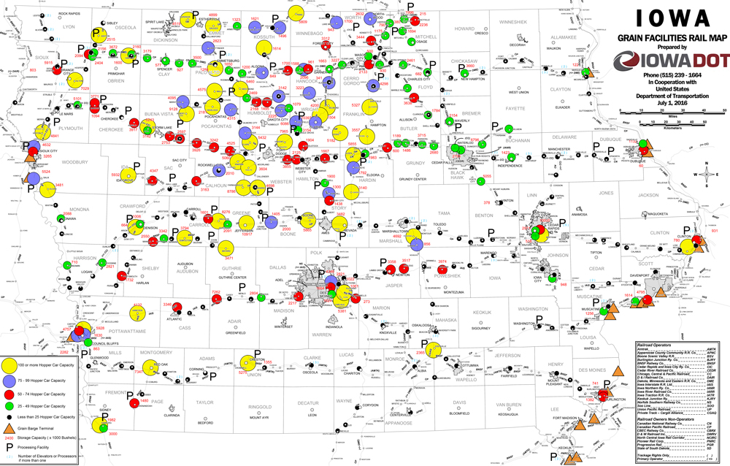](https://iowaculture.gov/sites/default/files/primary-sources/images/history-education-pss-geography2-grain-source.jpg)

Courtesy of the Iowa Department of Transportation, 1 July 2016.

**Title:** Iowa Grain Facilities Rail Map, July 1, 2016

**Description:** This map shows the grain facilities across the state in relation to the railways as of July 1, 2016. The map also shows the grain facilities' hopper car capacity across Iowa.

**Question:** Which areas of the state have more grain distribution locations? Why do you think this is the case? How would having close access to grain distribution locations help farmers or manufacturers?

**[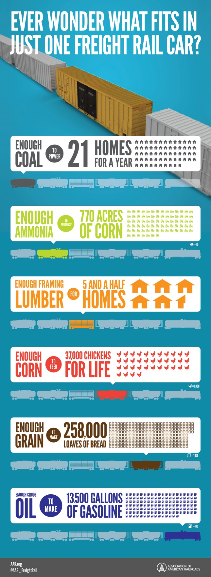](https://iowaculture.gov/sites/default/files/primary-sources/images/history-education-pss-geography2-railcar-source.jpg)What Fits in a Rail Car? Infographic, 2016**

Courtesy of Association of American Railroads, 2016.

**Title:** What Fits in a Rail Car? Infographic, 2016

**Description:** The infographic from the Association of American Railroads shows what can fit in one freight rail car. A quick look at the graphic shows such commodities such as coal, ammonia, lumber, corn, grain and oil.

**Question:** Why do you think the American Association of Railroads highlighted these materials for their infographic?

**Farmers Load Potatoes onto Trian, 1903**

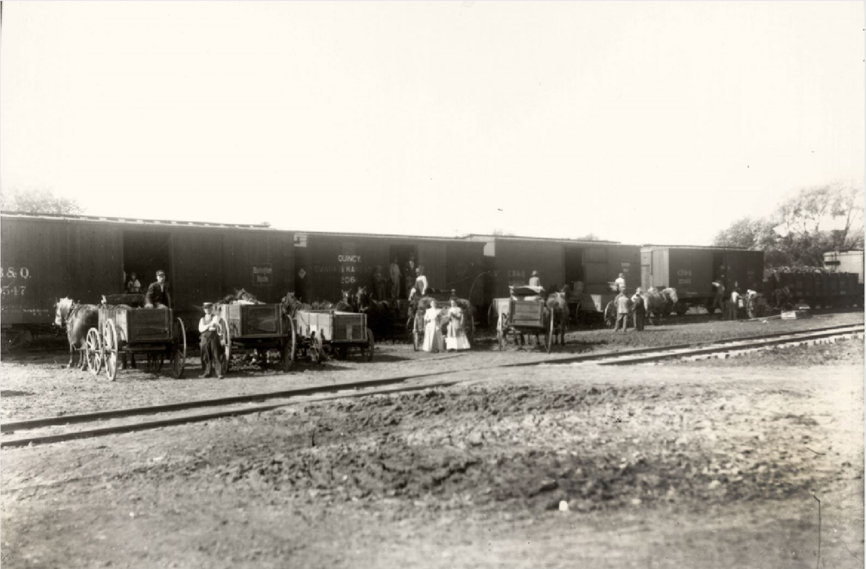

Courtesy of State Historical Society of Iowa, Ralston, Samuel, 1903

**Title:** Farmers Load Potatoes onto Trian, 1903

**Description:** Residents of Iowa brought wagons full of potatoes to the train depot in Lacona, Iowa. The potatoes were loaded onto a Chicago, Burlington & Quincy railcar in the fall of 1903.

**Question:** Most people think of Iowa farmers raising corn and soybeans today. What commodity did these farmers load onto the rail car? What could this tell us about how the commodities that Iowa farmers produce change over time?

**Pacific Fruit Express, Date Unknown**

[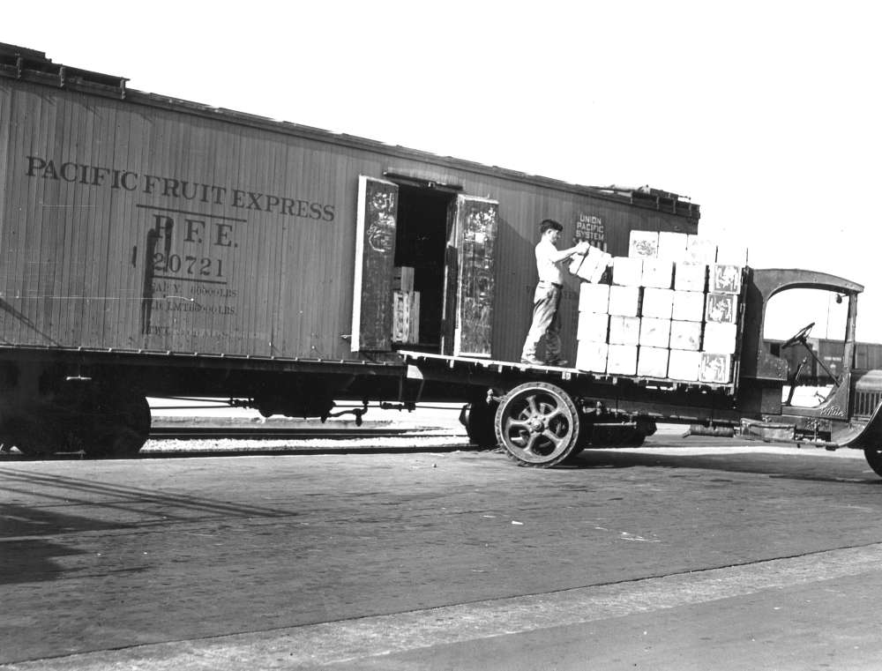](https://iowaculture.gov/sites/default/files/primary-sources/images/history-education-pss-geography2-fruit-source.jpg)

Courtesy Union Pacific Railroad Company Museum, Date Unknown.

**Title:** Pacific Fruit Express, Date Unknown

**Description:** The photo shows a young man loading fruit from a delivery truck onto rail car. Also known as the Pacific Fruit Express, this train car belonged to an American railroad refrigerator car leasing company that at one point was the largest refrigerator car operator in the world. The company was founded in late 1906 as a joint venture between the Union Pacific Railroad Company and the Southern Pacific railroads.

**Question:** How did access to refrigeration change trade for perishable items such as meat, cheese and produce? Infer how that may affect people and society both positively and negatively. How were goods transported between producers and consumers before the railroad? Predict how changes in transportation methods benefitted the consumer. The producer? Who would be negatively impacted by these changes?